Working With Text

10.1 Introduction
A large number of the files in a typical file system are text files. Text files only contain text, no formatting features that you might see in a word processing file.
Because there are so many of these files on a typical Linux system, a significant number of commands exist to help users manipulate text files. There are commands to both view and modify these files in various ways.
Additionally, there are features available for the shell to control the output of commands, so instead of having the output placed in the terminal window, the output can be redirected into another file or another command. These redirection features provide users with a much more flexible and powerful environment to work within.

10.1.1 Viewing Files in the Terminal
The cat command, short for concatenate, is a simple but useful command whose functions include creating and displaying text files, as well as combining copies of text files. One of the most popular uses of cat is to display the content of text files. To display a file in the standard output using the cat command, type the command followed by the filename:
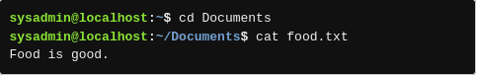

10.1.2 Viewing Files Using a Pager
For larger files, use a pager command to view the contents. Pager commands display one page of data at a time, allowing you to move forward and backward in the file by using movement keys.
There are two commonly used pager commands:
- The less command provides a very advanced paging capability. It is usually the default pager used by commands like the man command.
- The more command has been around since the early days of UNIX. While it has fewer features than the less command, however, the less command isn't included with all Linux distributions. The more command is always available.

10.1.2.1 Pager Movement Commands
To view a file with the less command, pass the file name as an argument:

how to move in more and less at the same time:
‌
Key | Movement
Spacebar | Window forward
B | Window backward
Enter | Line forward
Q | Exit
H | Help

10.1.2.2 Pager Searching Commands
There are two ways to search in the less command: searching forward or backward from your current position.
To start a search to look forward from your current position, use the slash / key. Then, type the text or pattern to match and press the Enter key.
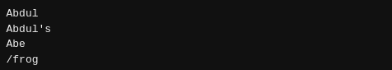

To search backward from your current position, press the question mark ? key, then type the text or pattern to match and press the Enter key. The cursor moves backward to the first match it can find or reports that the pattern cannot be found.
If more than one match can be found by a search, then use the n key to move the next match and use the Shift+N key combination to go to a previous match.

10.1.3 Head and Tail
The head and tail commands are used to display only the first few or last few lines of a file, respectively (or, when used with a pipe, the output of a previous command). By default, the head and tail commands display ten lines of the file that is provided as an argument.
Passing a number as an option will cause both the head and tail commands to output the specified number of lines, instead of the standard ten. For example to display the last five lines of the /etc/sysctl.conf file use the -5 option:
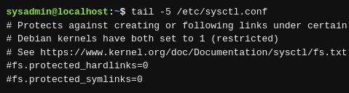

The -n option can also be used to indicate how many lines to output. Pass a number as an argument to the option:
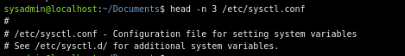

Negative Value Option
Traditionally in UNIX, the number of lines to output would be specified as an option with either command, so -3 meant to show three lines. For the tail command, either -3 or -n -3 still means show three lines.
However, the GNU version of the head command recognizes -n -3 as show all but the last three lines, and yet the head command still recognizes the option -3 as show the first three lines.

Positive Value Option
The GNU version of the tail command allows for a variation of how to specify the number of lines to be printed. If the -n option is used with a number prefixed by the plus sign, then the tail command recognizes this to mean to display the contents starting at the specified line and continuing all the way to the end.

10.2 Command Line Pipes
The pipe | character can be used to send the output of one command to another.
To more easily view the beginning of the output, pipe it to the head command. The following example displays only the first ten lines:
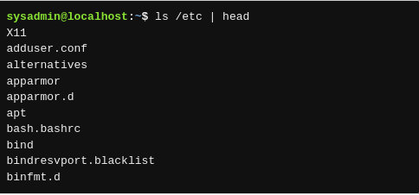

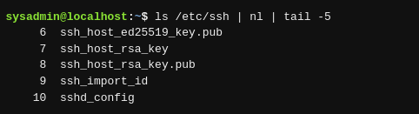

10.3 Input/Output Redirection
Input/Output (I/O) redirection allows for command line information to be passed to different streams. Before discussing redirection, it is important to understand the standard streams.

STDIN
Standard input, or STDIN, is information entered normally by the user via the keyboard. When a command prompts the shell for data, the shell provides the user with the ability to type commands that, in turn, are sent to the command as STDIN.

STDOUT
Standard output, or STDOUT, is the normal output of commands. When a command functions correctly (without errors) the output it produces is called STDOUT. By default, STDOUT is displayed in the terminal window where the command is executing. STDOUT is also known as stream or channel #1.

STDERR
Standard error, or STDERR, is error messages generated by commands. By default, STDERR is displayed in the terminal window where the command is executing. STDERR is also known as stream or channel #2.
‌⁠​​⁠​
I/O redirection allows the user to redirect STDIN so that data comes from a file and STDOUT/STDERR so that output goes to a file. Redirection is achieved by using the arrow < > characters.

10.3.1 STDOUT
Using the > character, the output can be redirected to a file instead:

It is also possible to preserve the contents of an existing file by appending to it. Use two arrow >> characters to append to a file instead of overwriting it:
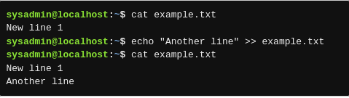

10.3.2 STDERR
STDERR can be redirected similarly to STDOUT. When using the arrow character to redirect, stream #1 (STDOUT) is assumed unless another stream is specified. Thus, stream #2 must be specified when redirecting STDERR by placing the number 2 preceding the arrow > character.
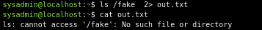

10.3.3 Redirecting Multiple Streams
It is possible to direct both the STDOUT and STDERR of a command at the same time.
If only the STDOUT is sent to a file, STDERR is still printed to the screen:
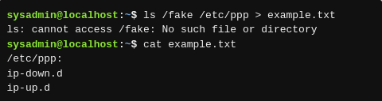

If only the STDERR is sent to a file, STDOUT is still printed to the screen:
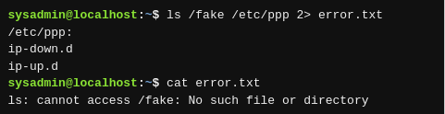

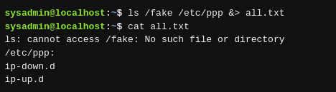
Both STDOUT and STDERR can be sent to a file by using the ampersand & character in front of the arrow > character. The &> character set means both 1> and 2>:

Note that when you use &>, the output appears in the file with all of the STDERR messages at the top and all of the STDOUT messages below all STDERR messages.
If you don't want STDERR and STDOUT to both go to the same file, they can be redirected to different files by using both > and 2>. For example, to direct STDOUT to example.txt and STDERR to error.txt execute the following:
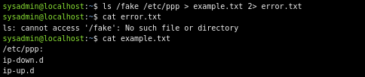

10.3.4 STDIN
if you don't specify a filename as an argument, they revert to using STDIN to get data. For example, consider the following cat command:
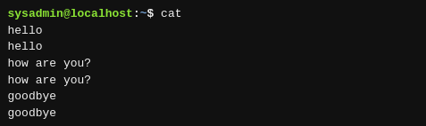

The first command in the example below redirects the output of the cat command to a newly created file called new.txt. This action is followed up by providing the cat command with the new.txt file as an argument to display the redirected text in STDOUT.
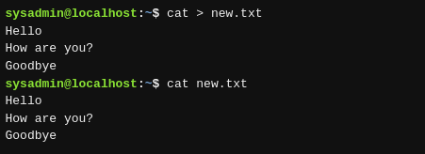

a new command called tr. This command takes a set of characters and translates them into another set of characters.
For example, to capitalize a line of text use the tr command as follows:
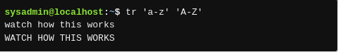

he tr command does not support file name arguments.
It is possible, however, to tell the shell to get STDIN from a file instead of from the keyboard by using the < character:
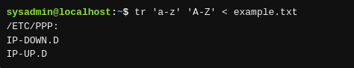

One last note to save the resulting output, redirect it into another file:
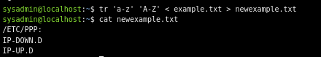

10.4 Sorting Files or Input
The sort command can be used to rearrange the lines of files or input in either dictionary or numeric order. The following example creates a small file, using the head command to grab the first 5 lines of the /etc/passwd file and send the output to a file called mypasswd.
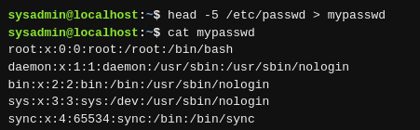

Now we will sort the mypasswd file:
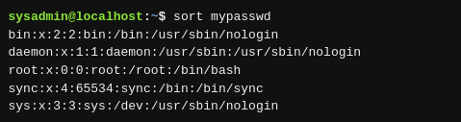

10.4.1 Fields and Sort Options
The sort command can rearrange the output based on the contents of one or more fields. Fields are determined by a field delimiter contained on each line. In computing, a delimiter is a character that separates a string of text or data; it defaults to whitespace, like spaces or tabs.
The following command can be used to sort the third field of the mypasswd file numerically. Three options are used to achieve this sort:
Option | Function
-t: | The -t option specifies the field delimiter. If the file or input is separated by a delimiter other than whitespace, for example a comma or colon, the -t option will allow for another field separator to be specified as an argument.  The mypasswd file used in the previous example uses a colon : character as a delimiter to separate the fields, so the following example uses the -t: option.
-k3 | The -k option specifies the field number. To specify which field to sort by, use the -k option with an argument to indicate the field number, starting with 1 for the first field.  The following example uses the -k3 option to sort by the third field.
-n | This option specifies the sort type.  The third field in the mypasswd file contains numbers, so the -n option is used to perform a numeric sort.

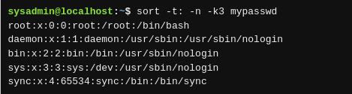

10.5 Viewing File Statistics
The wc command provides the number of lines, words and bytes (1 byte = 1 character in a text file) for a file, and a total line count if more than one file is specified. By default, the wc command allows for up to three statistics to be printed for each file provided, as well as the total of these statistics if more than one filename is provided:
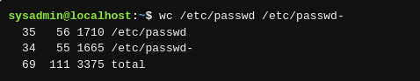

It is also possible to view only specific statistics, by using the -l option to show just the number of lines, the -w option to show just the number of words, the -c option to show just the number of bytes, or any combination of these options.
The wc command can be useful for counting the number of lines output by some other command through a pipe. For example, if you wanted to know the total number of files in the /etc directory, pipe the output of ls to wc and count only the number of lines:
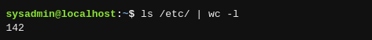

10.6 Filter File Sections
The cut command can extract columns of text from a file or standard input. It’s primarily used for working with delimited database files. Again, delimited files are files that contain columns separated by a delimiter. These files are very common on Linux systems.
By default, the cut command expects its input to be separated by the tab character, but the -d option can specify alternative delimiters such as the colon or comma.
The -f option can specify which fields to display, either as a hyphenated range or a comma-separated list.
In the following example, the first, fifth, sixth and seventh fields from the mypasswd database file are displayed:
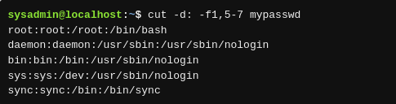

The cut command is also able to extract columns of text based upon character position with the -c option—useful when working with fixed-width database files or command outputs.
For example, the fields of the ls -l command are always in the same character positions. The following will display just the file type (character 1), permissions (characters 2-10), a space (character 11), and filename (characters 50+):
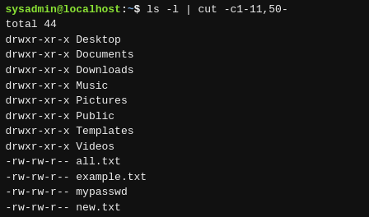

10.7 Filter File Contents
The grep command can be used to filter lines in a file or the output of another command that matches a specified pattern. That pattern can be as simple as the exact text that you want to match or it can be much more advanced through the use of regular expressions.
For example, to find all the users who can log in to the system with the BASH shell, the grep command can be used to filter the lines from the /etc/passwd file for the lines containing the pattern bash:
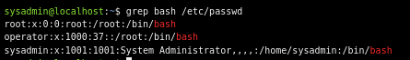

In some cases, it may not be important to find the specific lines that match the pattern, but rather how many lines match the pattern. The -c option provides a count of how many lines match:

The -n option to the grep command will display original line numbers. To display all lines and their line numbers in the /etc/passwd file which contain the pattern bash:
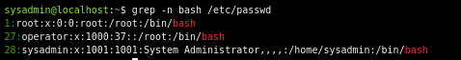

The -v option inverts the match, outputting all lines that do not contain the pattern. To display all lines not containing nologin in the /etc/passwd file:
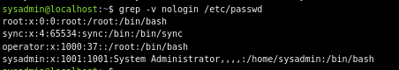

The -i option ignores the case (capitalization) distinctions. The following searches for the pattern the in newhome.txt, allowing each character to be uppercase or lowercase:
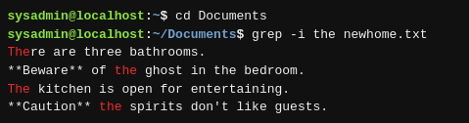

The -w option only returns lines which contain matches that form whole words. To be a word, the character string must be preceded and followed by a non-word character. Word characters include letters, digits, and the underscore character.
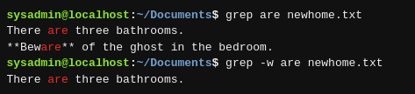

10.8 Basic Regular Expressions
Regular expressions, also referred to as regex, are a collection of normal and special characters that are used to find simple or complex patterns, respectively, in files. These characters are characters that are used to perform a particular matching function in a search.

Character | Matches
. | Any single character
[ ] | A list or range of characters to match one character  If the first character within the brackets is the caret ^, it means any character not in the list
* | The previous character repeated zero or more times
^ | If the first character in the pattern, the pattern must be at the beginning of the line to match, otherwise just a literal ^ character
$ | If the last character in the pattern, the pattern must be at the end of the line to match, otherwise just a literal $ character

While some of the regular expressions are unnecessarily quoted with single quotes, it is good practice to use single quotes around regular expressions to prevent the shell from trying to interpret special meaning from them.

10.8.1 Extended Regular Expressions
The use of extended regular expressions often requires a special option be provided to the command to recognize them. Historically, there is a command called egrep, which is similar to grep, but can understand extended regular expressions. Now, the egrep command is deprecated in favor of using grep with the -E option.
The following regular expressions are considered extended:
Character | Meaning
? | Matches previous character zero or one time, so it is an optional character
+ | Matches previous character repeated one or more times
| | Alternation or like a logical "or" operator

To match colo followed by zero or one u character followed by an r character:
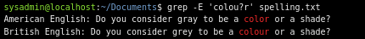

To match one or more e characters:
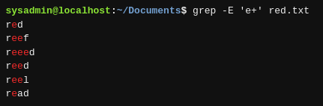

To match either gray or grey:


